GIT AND GITHUB -02

1.Install git.
git --version to check if git is installed or not


2.Create a repo in github with README.md and .ignore file.
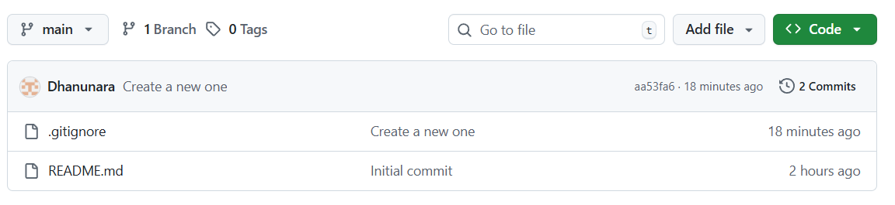

3.Clone the created repo to local.
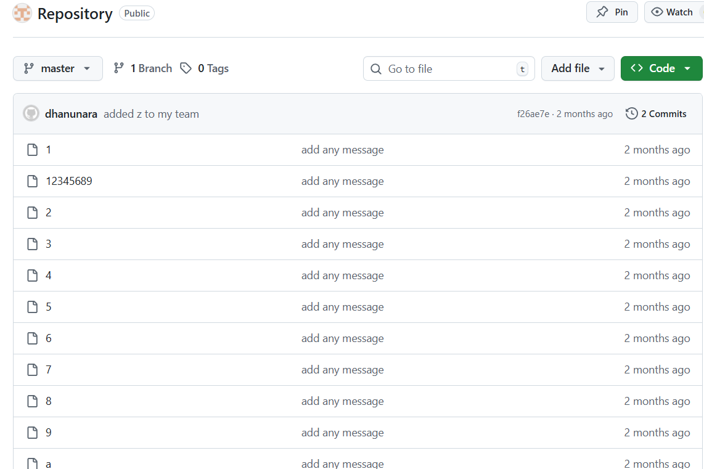
git clone and paste the ssh url of particular repository in gitbash it will clone the repository into the local machine.
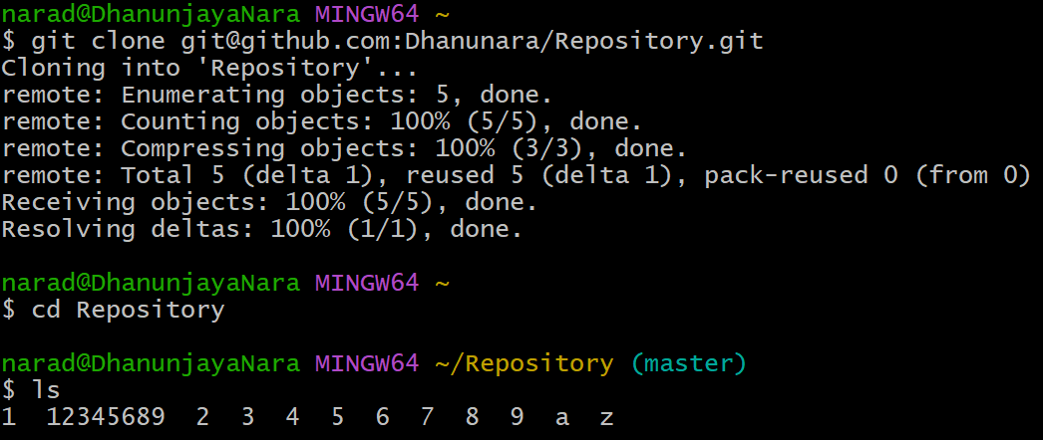

4.Create two files in local repo.
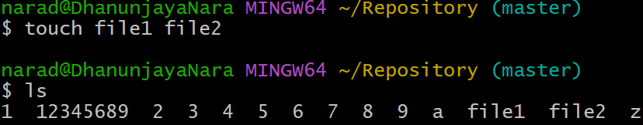

5.Commit two files and push to central repository.
First created two files.
After that we should commit those two and we should use git push -u origin master.
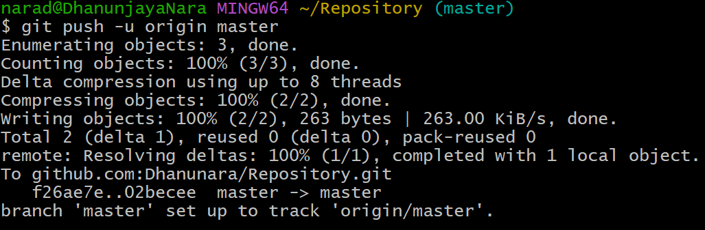


6.Create a branch in local and create a sample file and push to central.
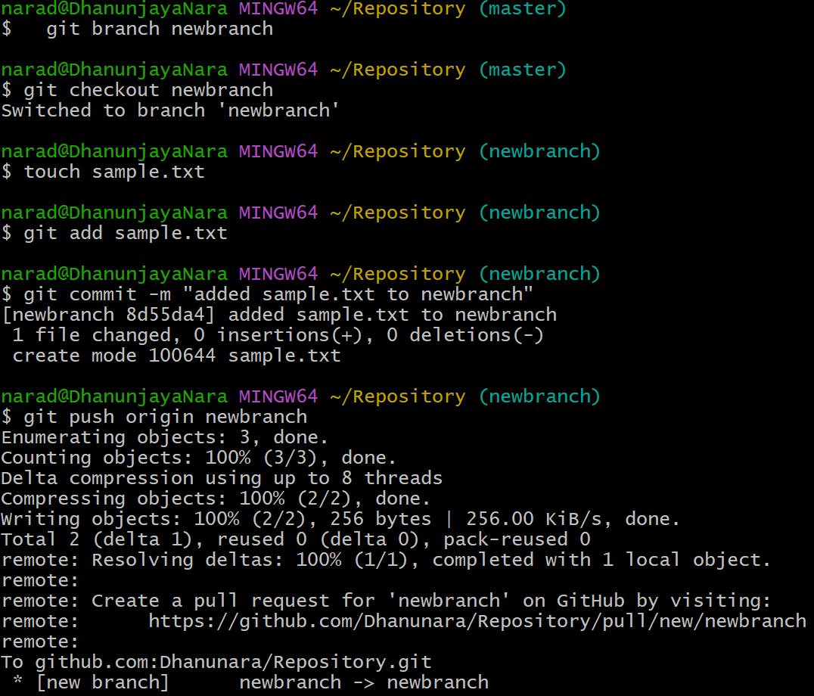
We should create new branch using git branch branchname . add and commit the file and git push origin branchname.

7.Create a branch in github and clone that to local.
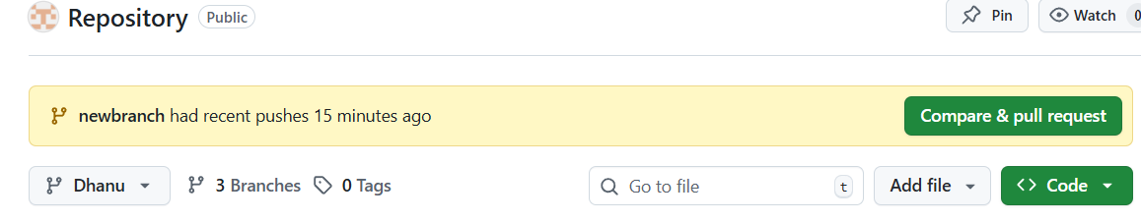
First we need to clone the central to local using git clone.
Then git fetch which will check all branches.
Then git checkout branchname to enter into newly created one.
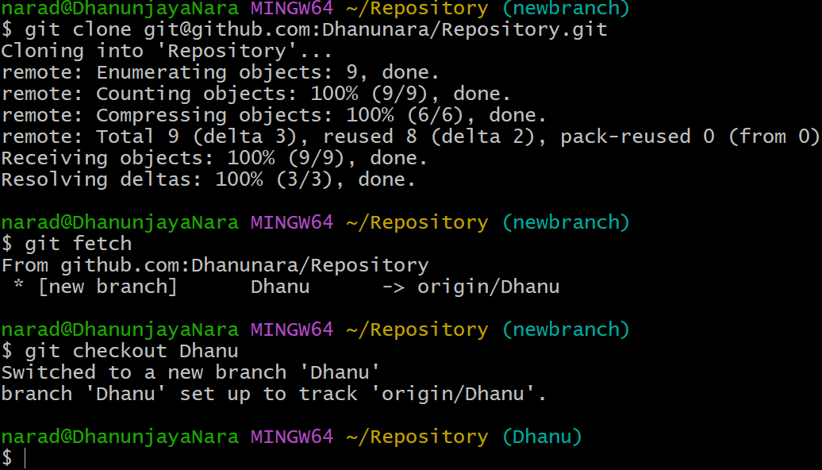

9.Merge the created branch with master in github by sending a pull request.
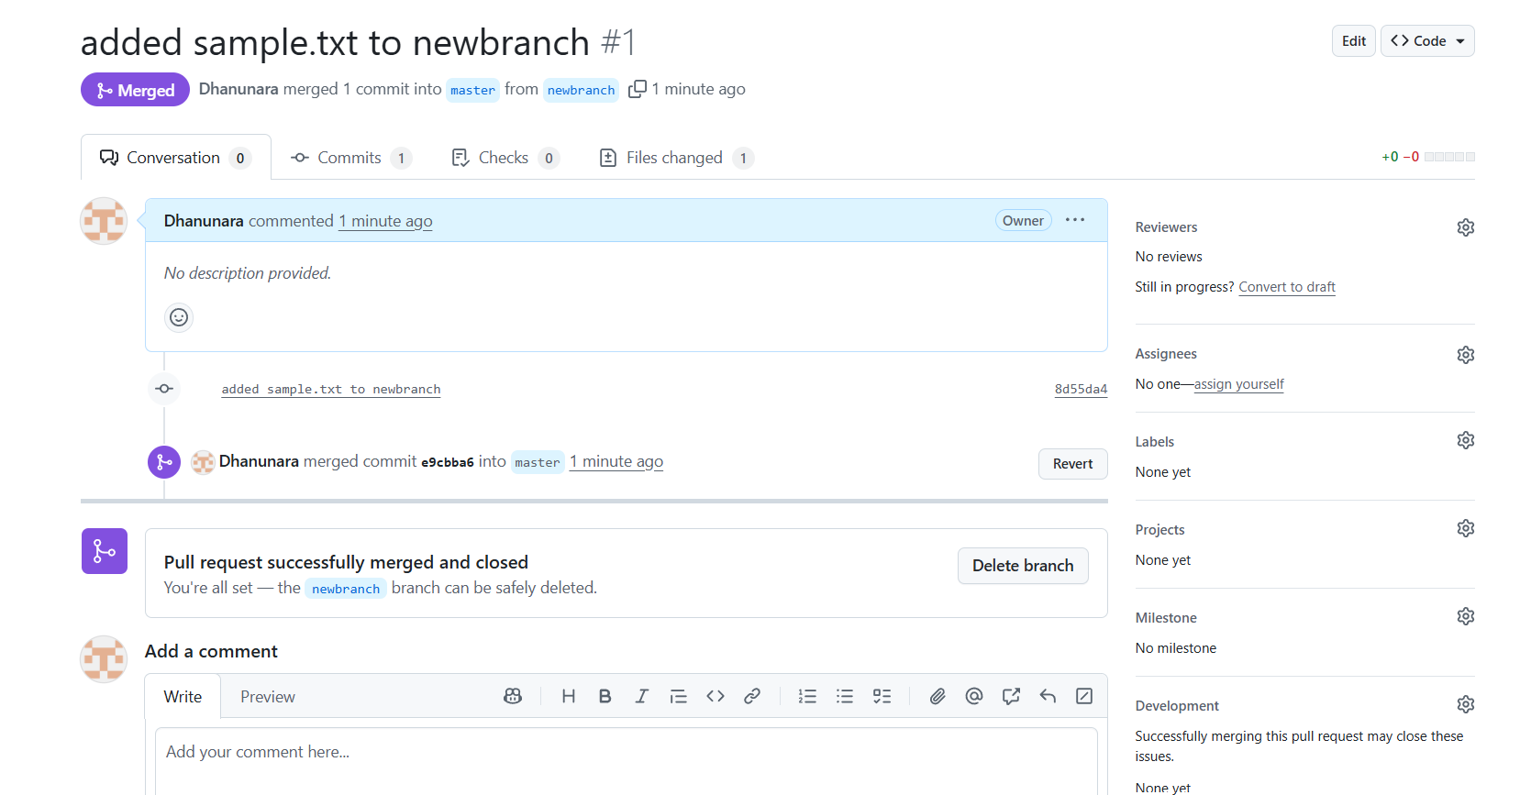

8.Merge the created branch with master in git local.
We use git merge and branch name to merge In local.
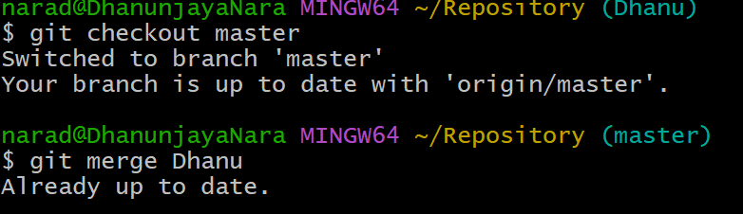

10.Create a file in local and send that to branch in github.
First we need to create a file using touch and add and commit that file.
And git push origin branchname.
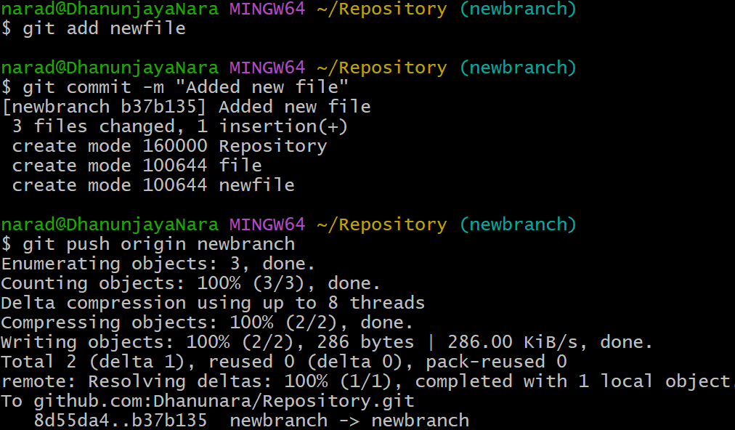

11.Clone only a branch from github to local.
Using git clone --branch newbranch --single-branch paste url it will clone only a branch from github to local.
After cloning change to Repository check the branch with git branch.
And if you do ls it will list all the files of particular repository.
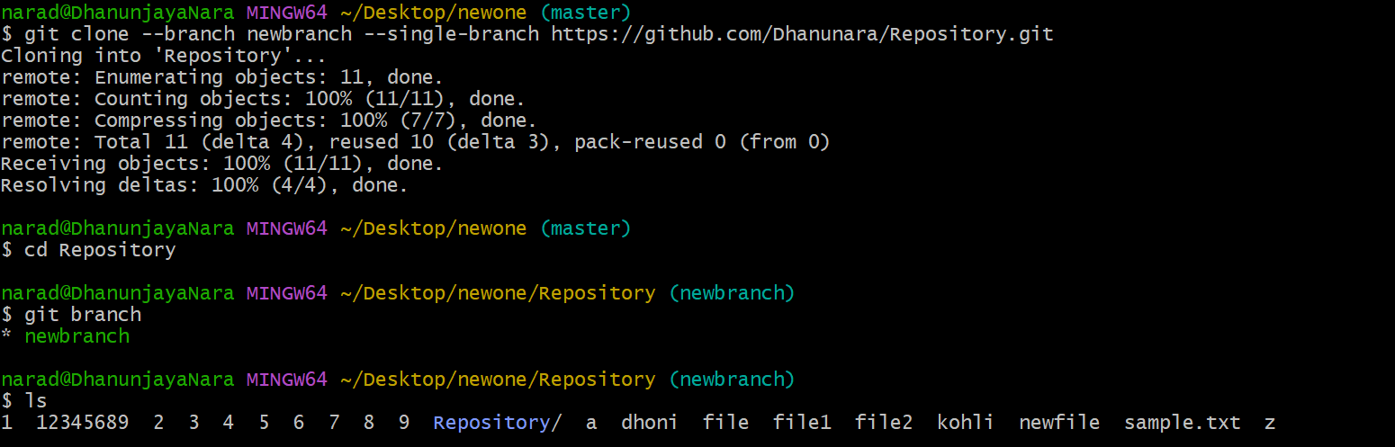

12.Create a file with all passwords and make that untrackable with git.
13.Make a commit and make that commit reset without saving changes.
First created a file and edited that file using vi and added that with commit message.
Then again edited that using vi and changed that commit message and added that. 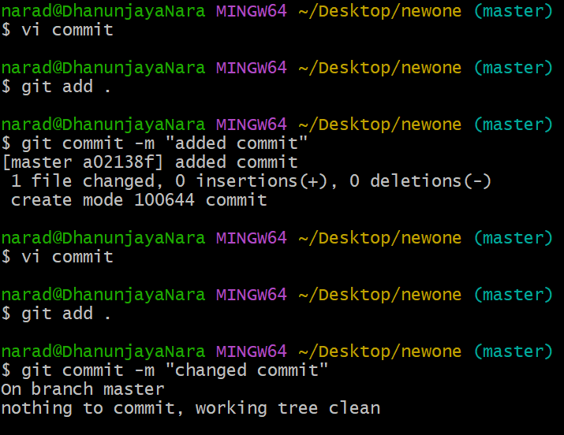

14.Revert a committed commit to the older version.
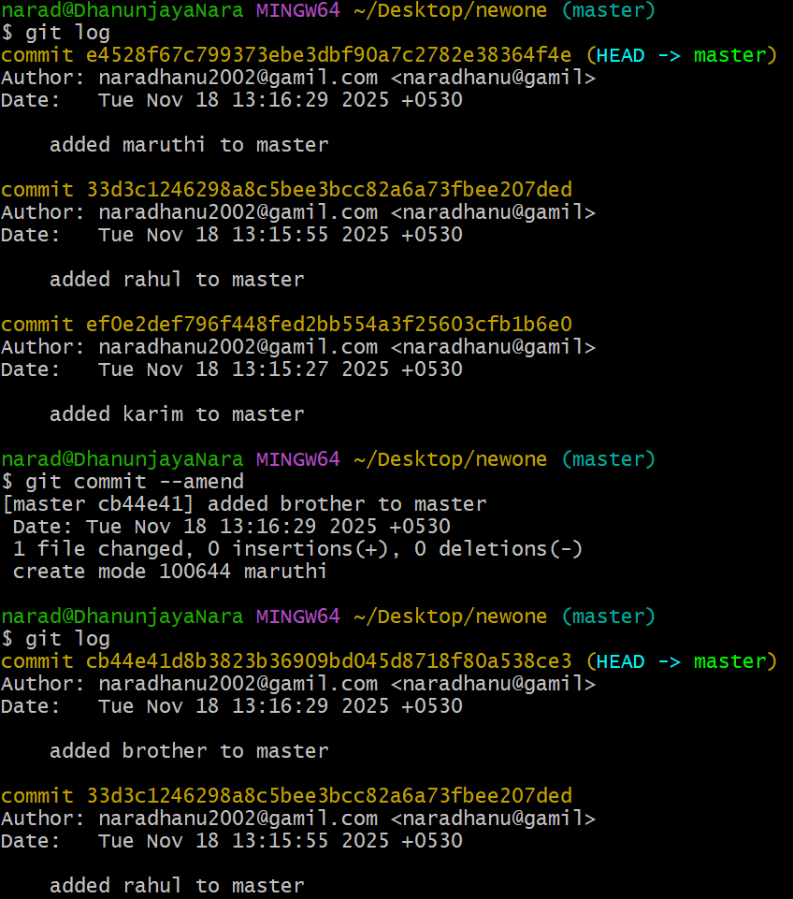
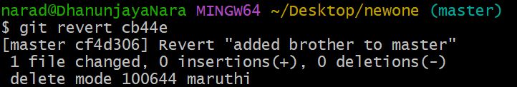

15.Push a file to stash without savings the changes and work on another file.
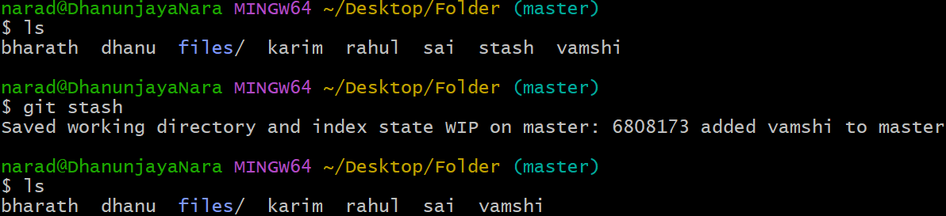
16. undo the stash file and start working on that again.
We use git stash to move particular file to stash memory.
We use stash pop to undo the the file moved to stash memory.
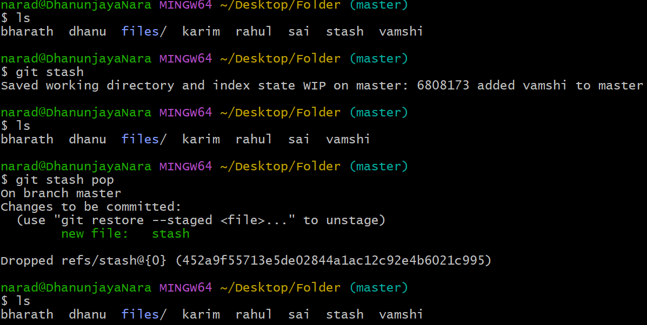

17.Generate a ssh-keygen and configure into github.
Use ssh-keygen and cat file and paste that in github.
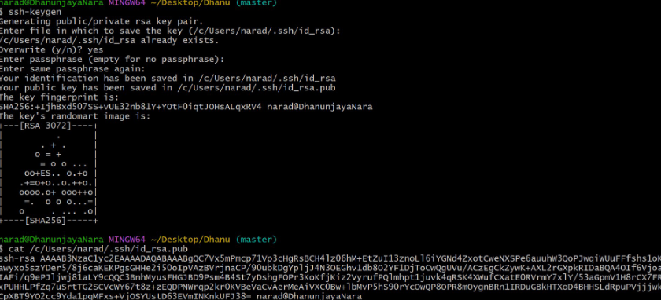

19.Basic understanding of .git file.
It stores all the internal data git needs.
It contains the entire history of your project.
It tracks every changes using logs.
It also stores remote branch information.

20.Check all the logs of git.
To see the logs we will use git log.
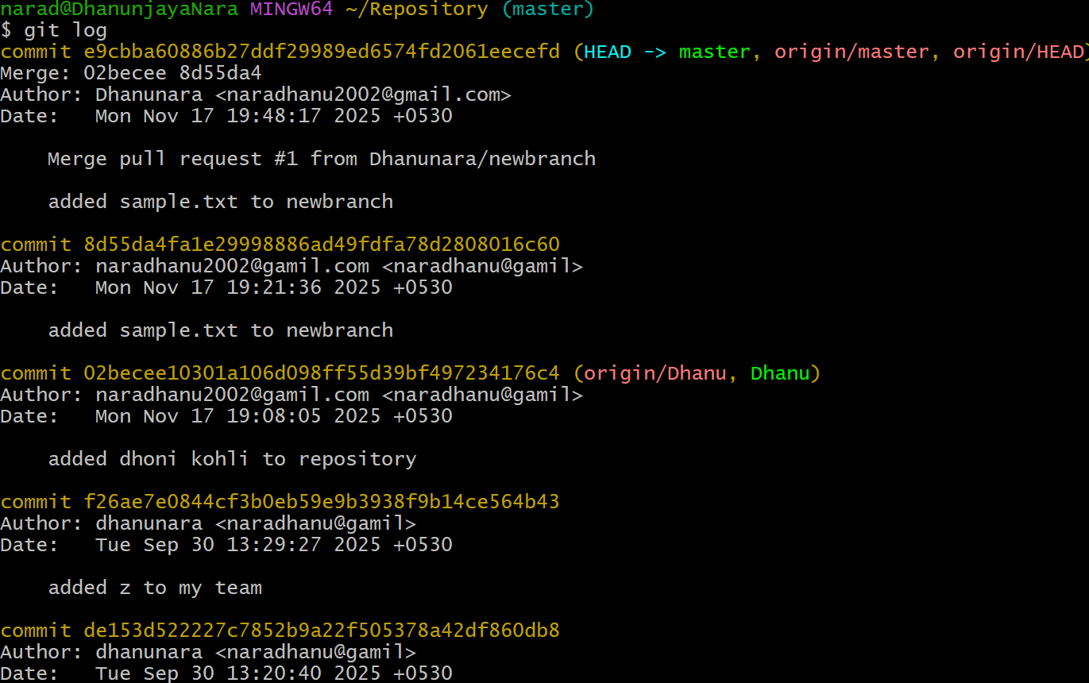

21.Rename the commit message.
First we should see the commits using git log.
And we should use git commit --amend to edit particular commit message.
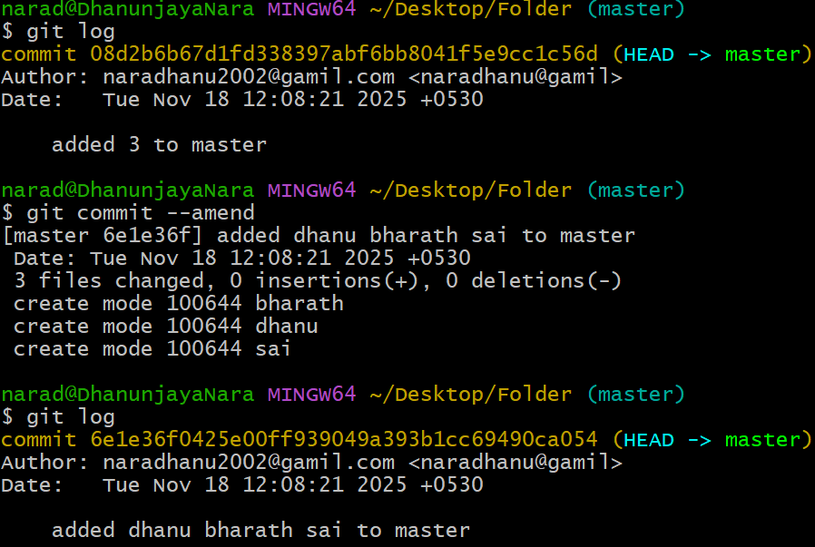

22.Merge multiple commits into single commit.
First we should check the commits using git log.
Then we should use git commit -I HEAD~3 to edit the commits you want to merge.
